Instructions for children on how to work in AIS "Artek".
«Young Diplomat School in Artek» competition.

In order to be eligible for a voucher, a child must complete three steps:
1. Register on the Artek. children website and fill out a profile.
2. To attach the competition task indicated in the position.
3. To apply for the planned shift, choosing the quota direction: Thematic quota of the partner of the ICC "Artek".

- Registration in AIS "Artek"

Go to http://артек.дети Choose 'Registration' tab.

Attention! If your child is already registered at artek.kids, you must proceed to Section II "Downloading Achievements". Registration as a parent is not required.

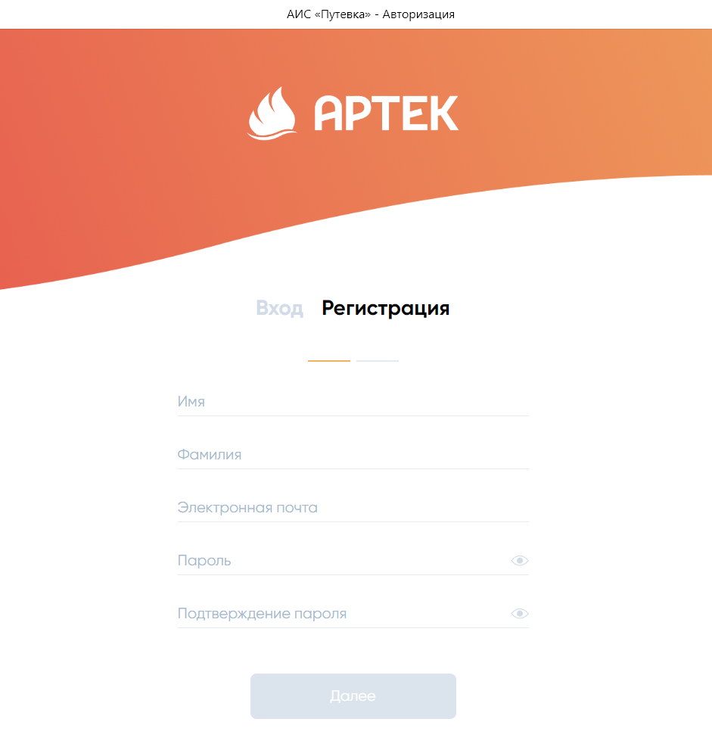
1. Fill in ALL fields carefully!

It is necessary to enter a valid e-mail, to which the registration confirmation will be sent. Once all the data is entered, the "Next" button will become active.

Be sure to write down and save your login information.
Go to your email and in the email from AIS, confirm your registration by clicking on the link.

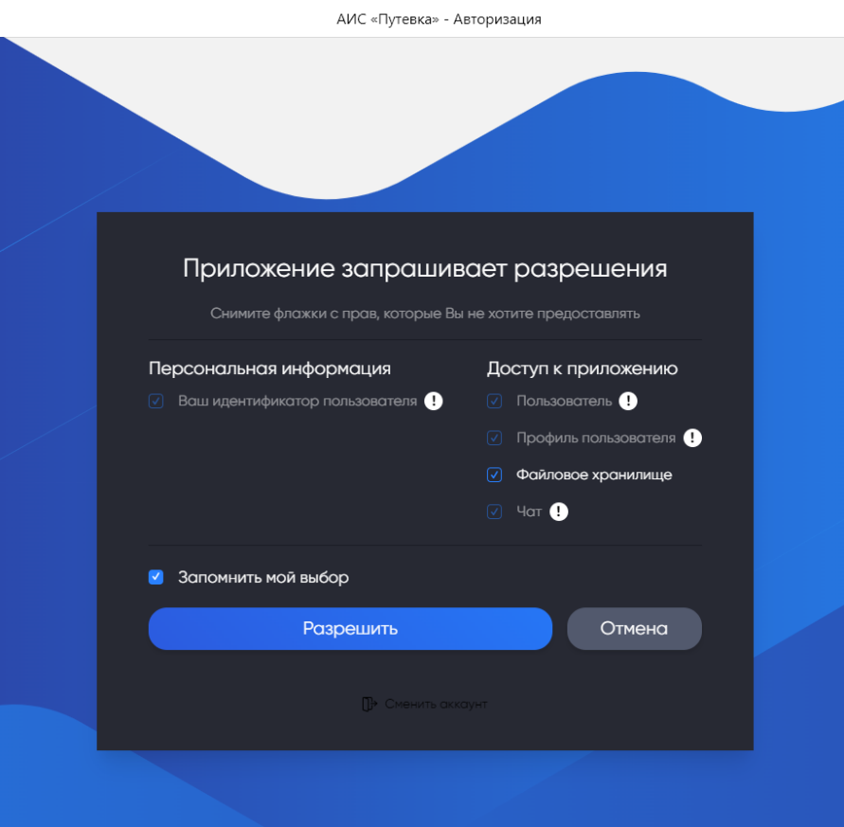
2. Выберите «Разрешить».

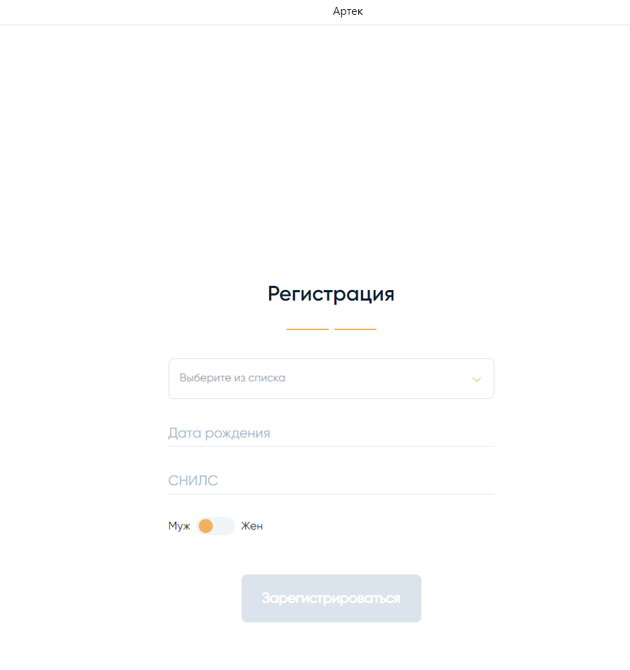

3. Select your country of residence from the drop-down list and enter your date of birth.
For citizens of the Russian Federation, the "SNILS" field is mandatory!
Indicate the gender of the child.
Click the "Register" button.

4. Enter your child's personal information (full name, phone number, photo upload is not required). Click the "Save" button. Save the changes in each section after you have entered the information.
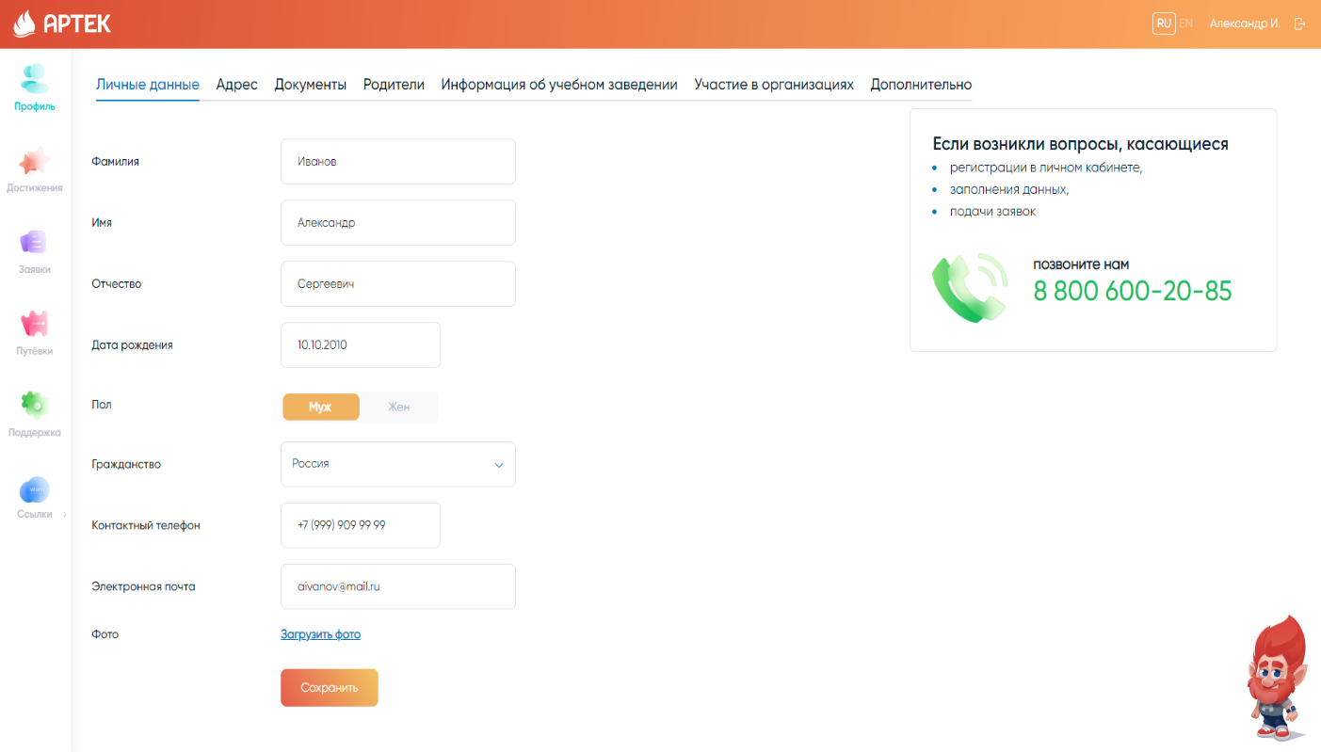

5. Fill in the "Address" section and click "Save".
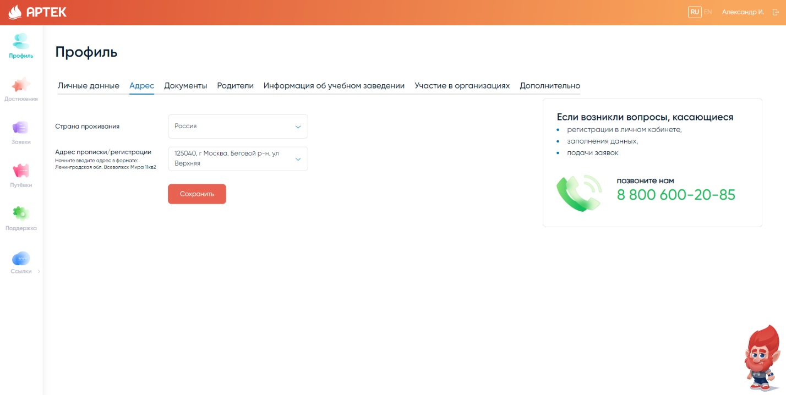

6. Fill in the "Documents" section. Carefully enter the number of your passport or birth certificate and the date of issue. Download scanned copies of your SNILS, passport or birth certificate by clicking on the "DOWNLOAD SCAN" button. The file size should not exceed 5 MB in JPEG, PDF, PNG, BMP formats. Click "Save".
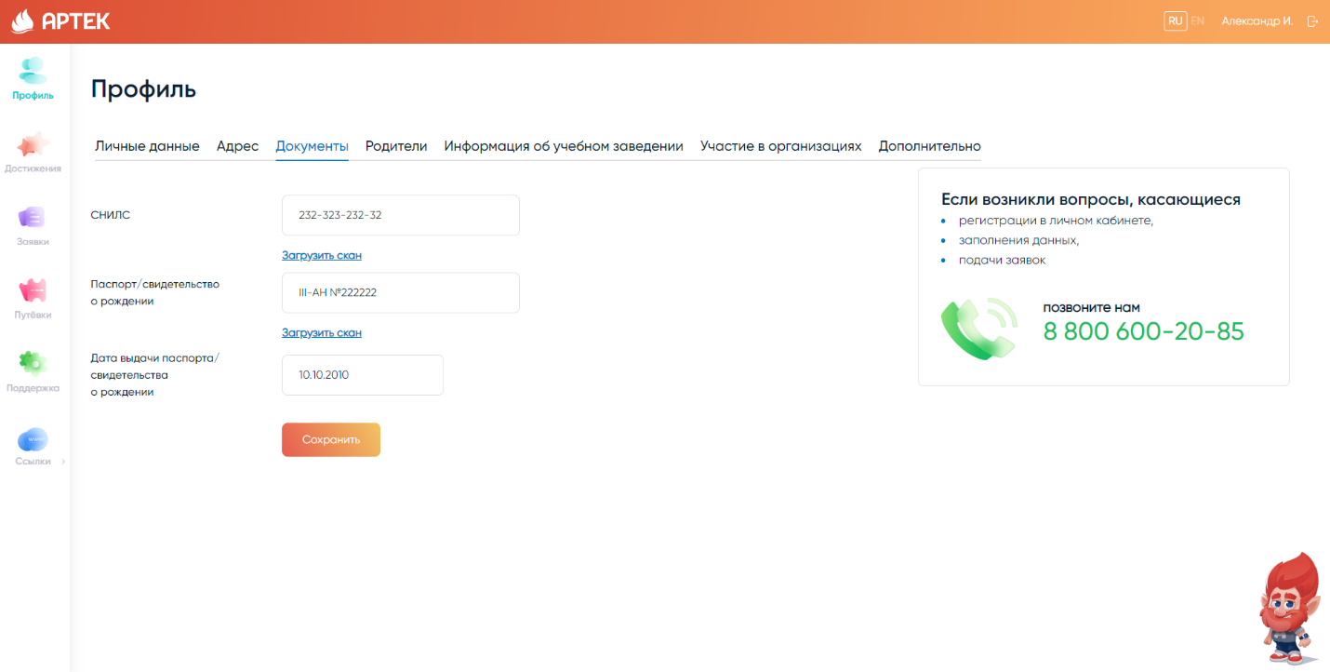

7. Fill out the “Parents” section. Valid phone numbers and email address of the parent or legal representative must be entered. Click «Save».

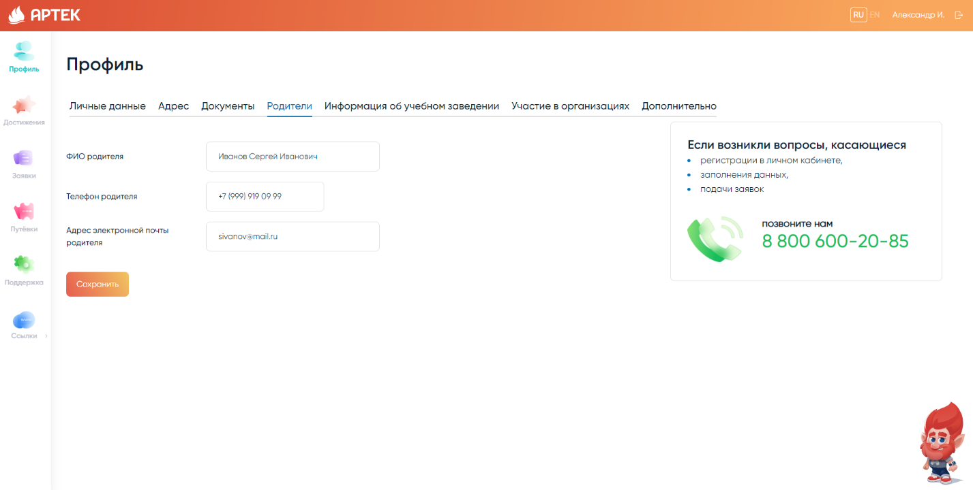

8. Enter information about the school. Select the school region, name, and class from the drop-down list. After entering the data, click "Save". If you can't find the name of the school or entered the wrong grade for your child, you need to contact Technical Support at 8 800 600-20-85.
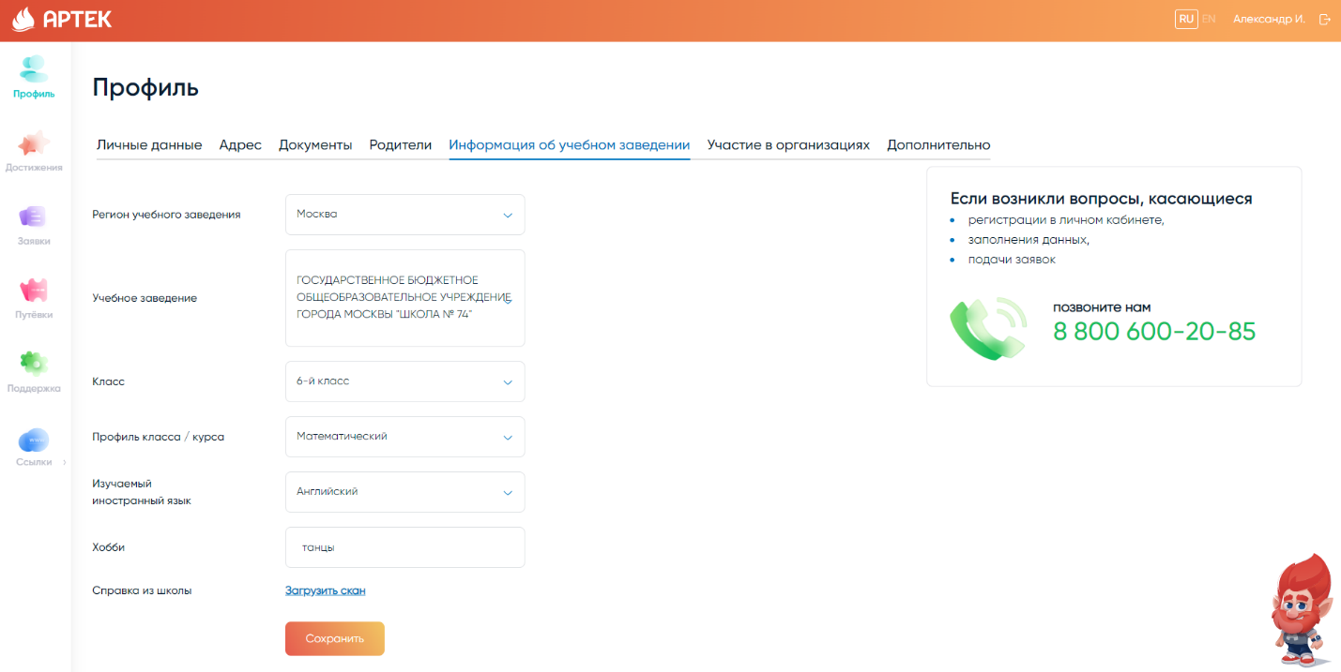

9. If your child participates in activities run by different organizations, you can indicate this in the "Participation in Organizations" section.
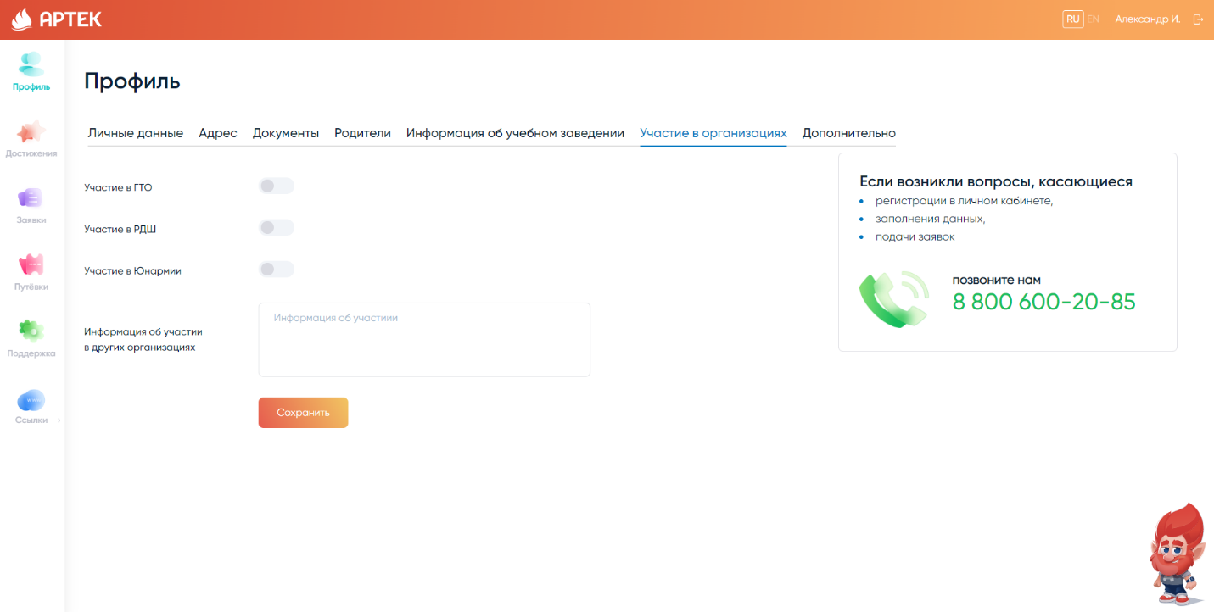

10. Enter the information in the "Extra" section. If your child has a disability or HIA, be sure to indicate this and upload a scanned copy of the supporting document. When you have entered the information, click «Save».
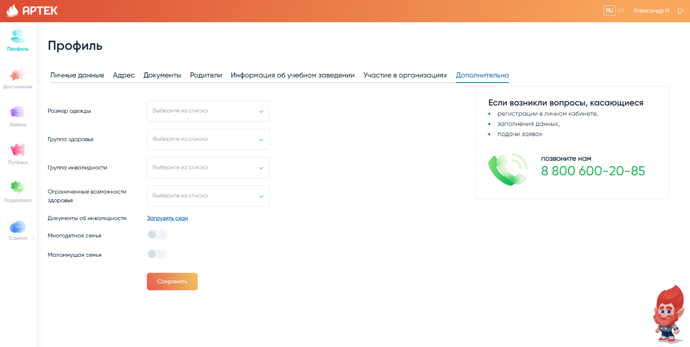

After completing all sections, be sure to check the correctness of the entered data!

- Downloading Achievements

Before uploading your achievements, please read the Statute on admission of children to Artek ICC Artek by quotas of subjects of the Russian Federation posted on artek.org website in the "Information for parents" section "How to get a trip to Artek" ("Statute").

1. Open the Achievements tab to upload contest entries, diplomas, certificates, thank-you notes, etc. Click the "Add Achievement" button.

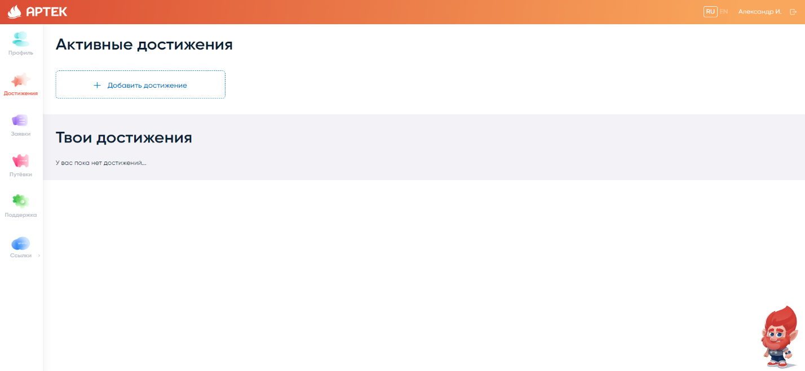

2. Specify the type of achievement "Partner". Select "Artek School of Diplomacy" from the drop-down list of available partners. Select the item "Young Diplomat School in Artek" from the drop-down list of available partners. Click "Next".
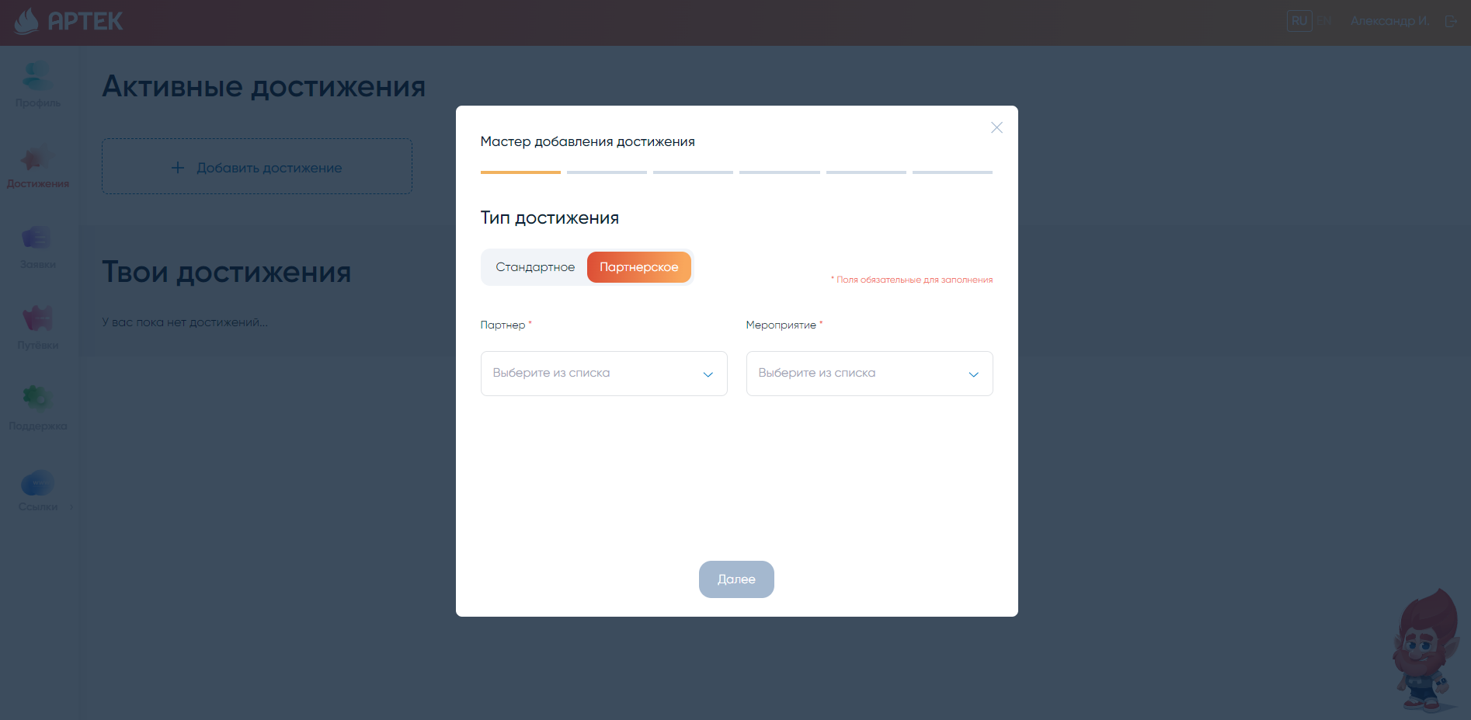

3. You can choose any place (it will not affect your rating).
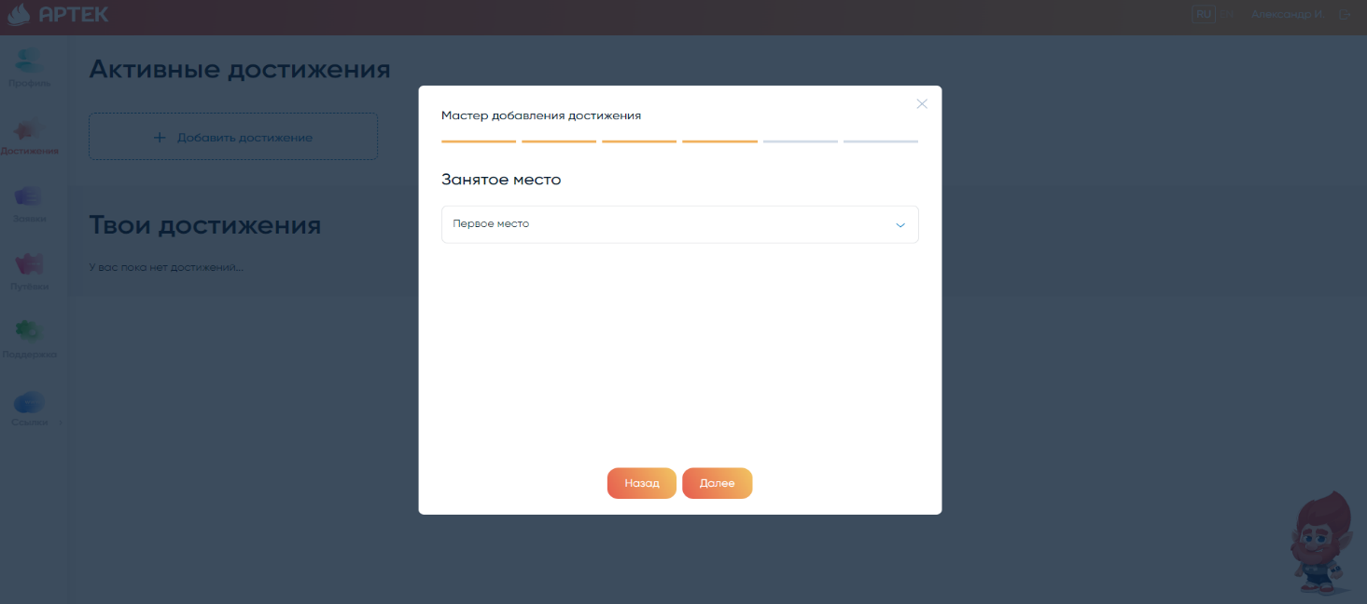

4. Upload a document (file with a link) and specify the date of the event (the start of the сontest).
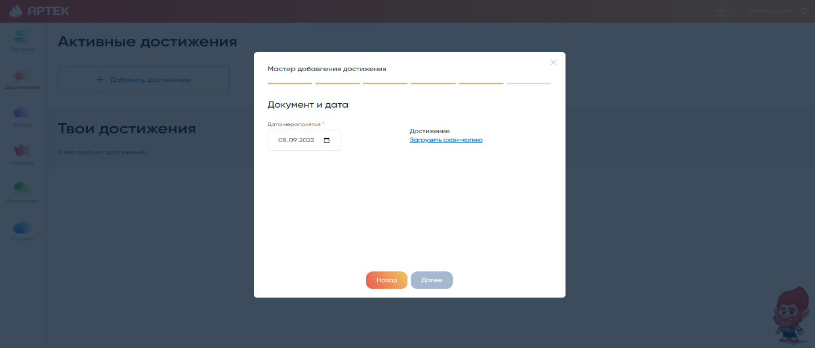

Once successfully added, all submissions, diplomas and certificates of merit will be available for future use in the application.

- Submitting an application

1. In order to submit an application, you need to open the "Applications" tab and click "Add Application".
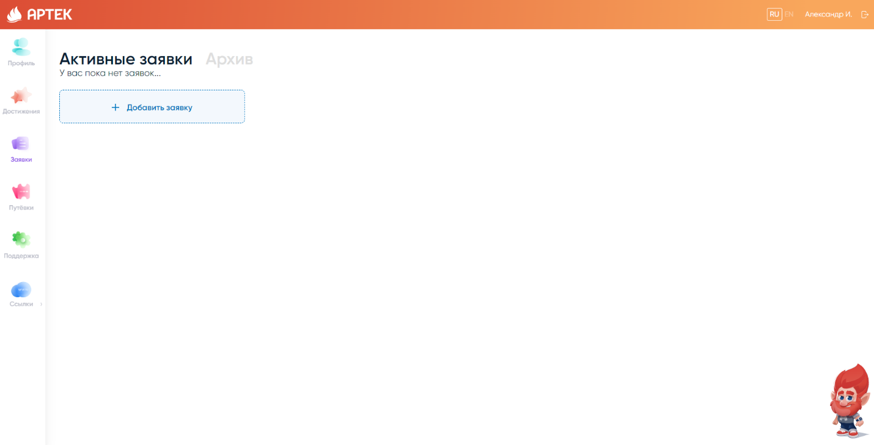

2. The next step is to choose the type of quota "Thematic quota of the ICC Artek partner".
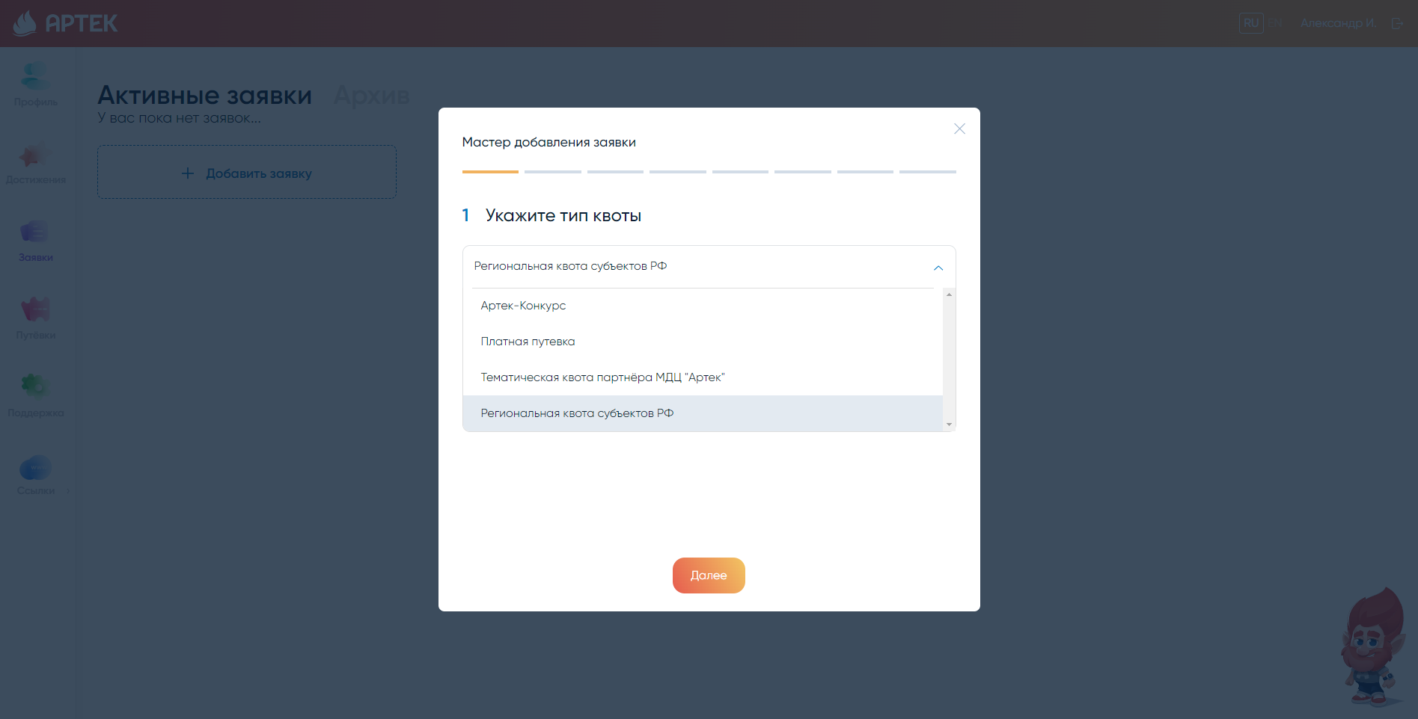

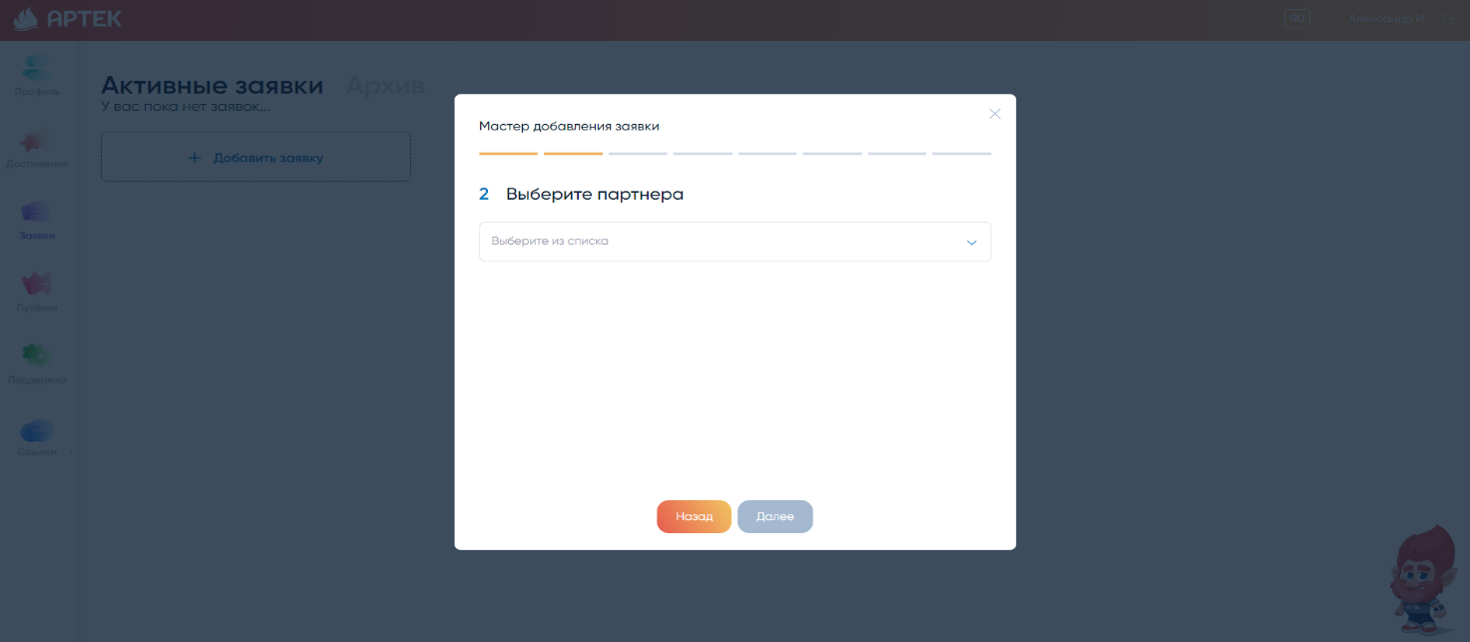
3. Choose from a list of partners "Young Diplomat School in Artek".

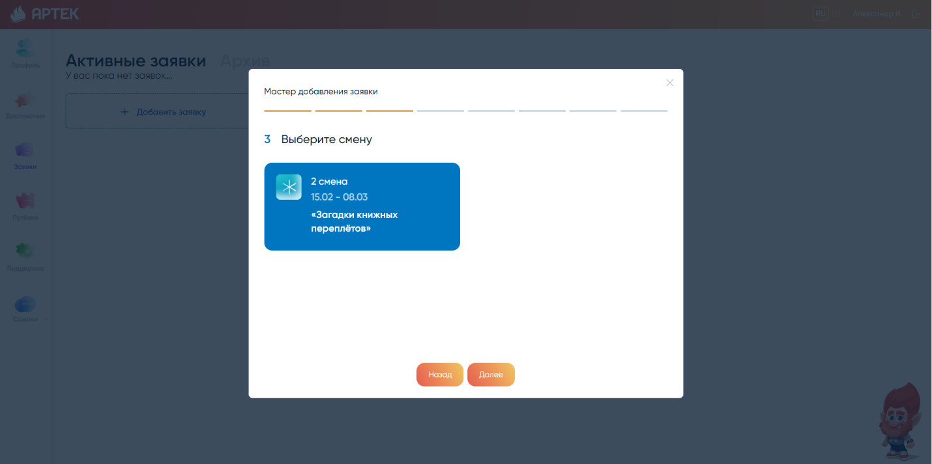
4. The third step provides a list of shifts available for application.

5. Next, you need to select the contest work and achievements that were uploaded earlier.
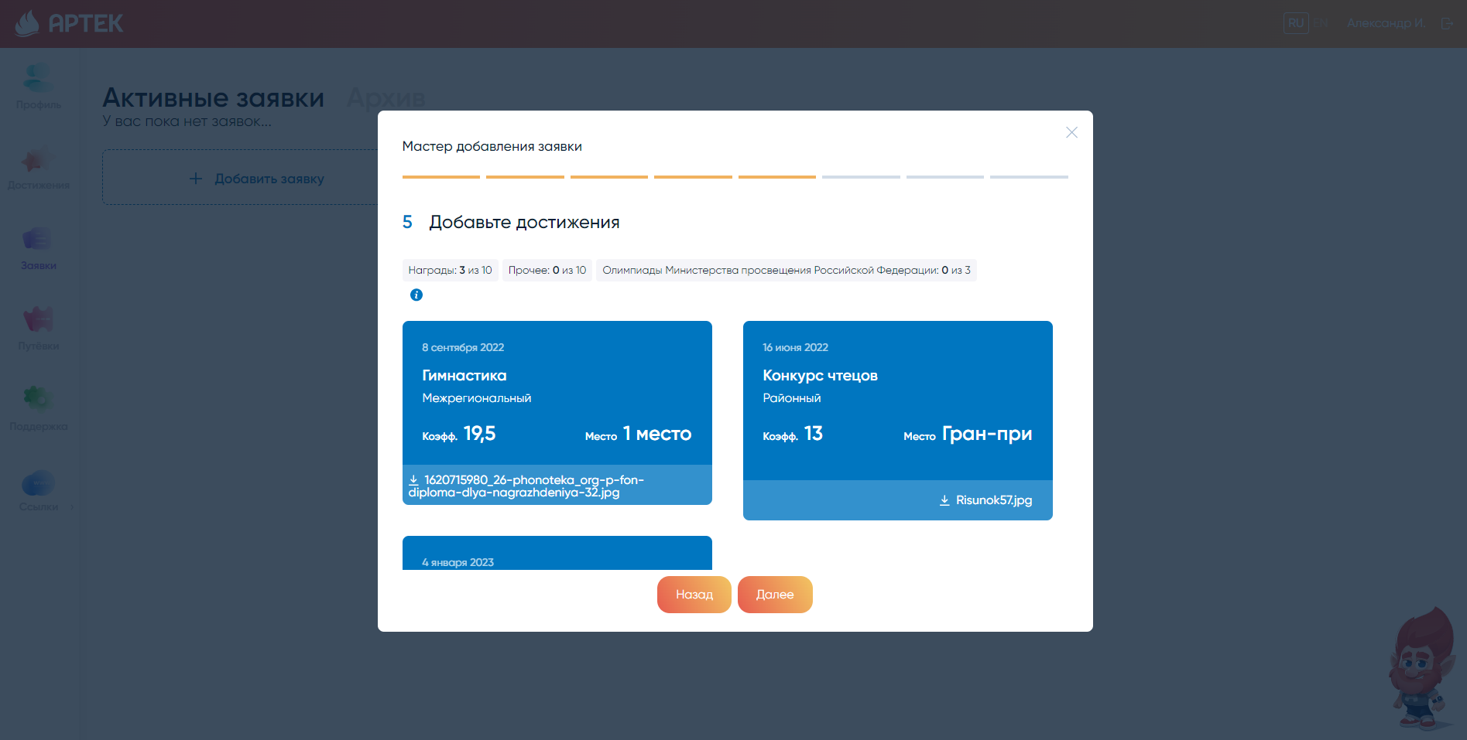

6. The system calculates a preliminary rating for the application and assigns it the "New" status. The final rating of the application is formed after the contest committee checks its achievements.
Before submitting an application, be sure to familiarize yourself with the rules and conditions of stay and medical centers of the Federal State Budgetary Institution "International Children's Center "Artek".
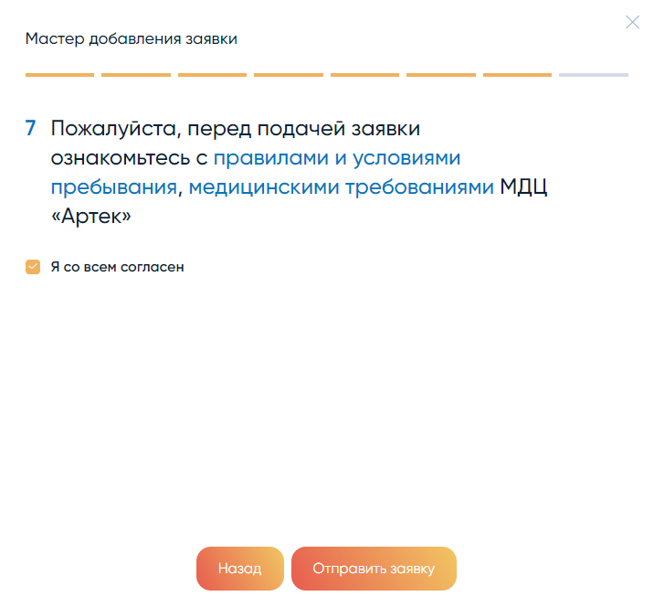
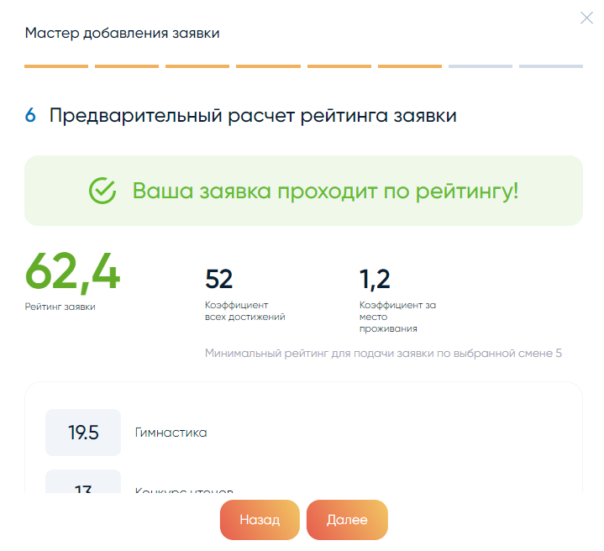

7. Then the operator checks your request and transfers to the status of "Accepted".

8. Applications which have passed the competitive selection are given the status "Voucher received". Such applications go to the "Tickets" section.
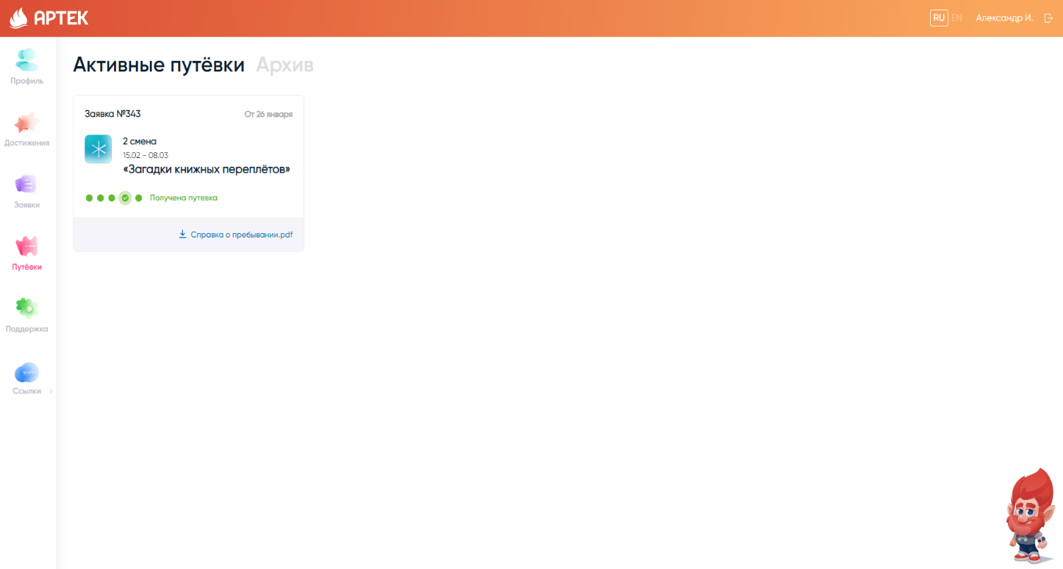

9. After receiving a voucher, you need to fill out and attach to the application all the requested documents (medical documents and documents for enrollment in the camp). Templates of documents can be found in the voucher itself.
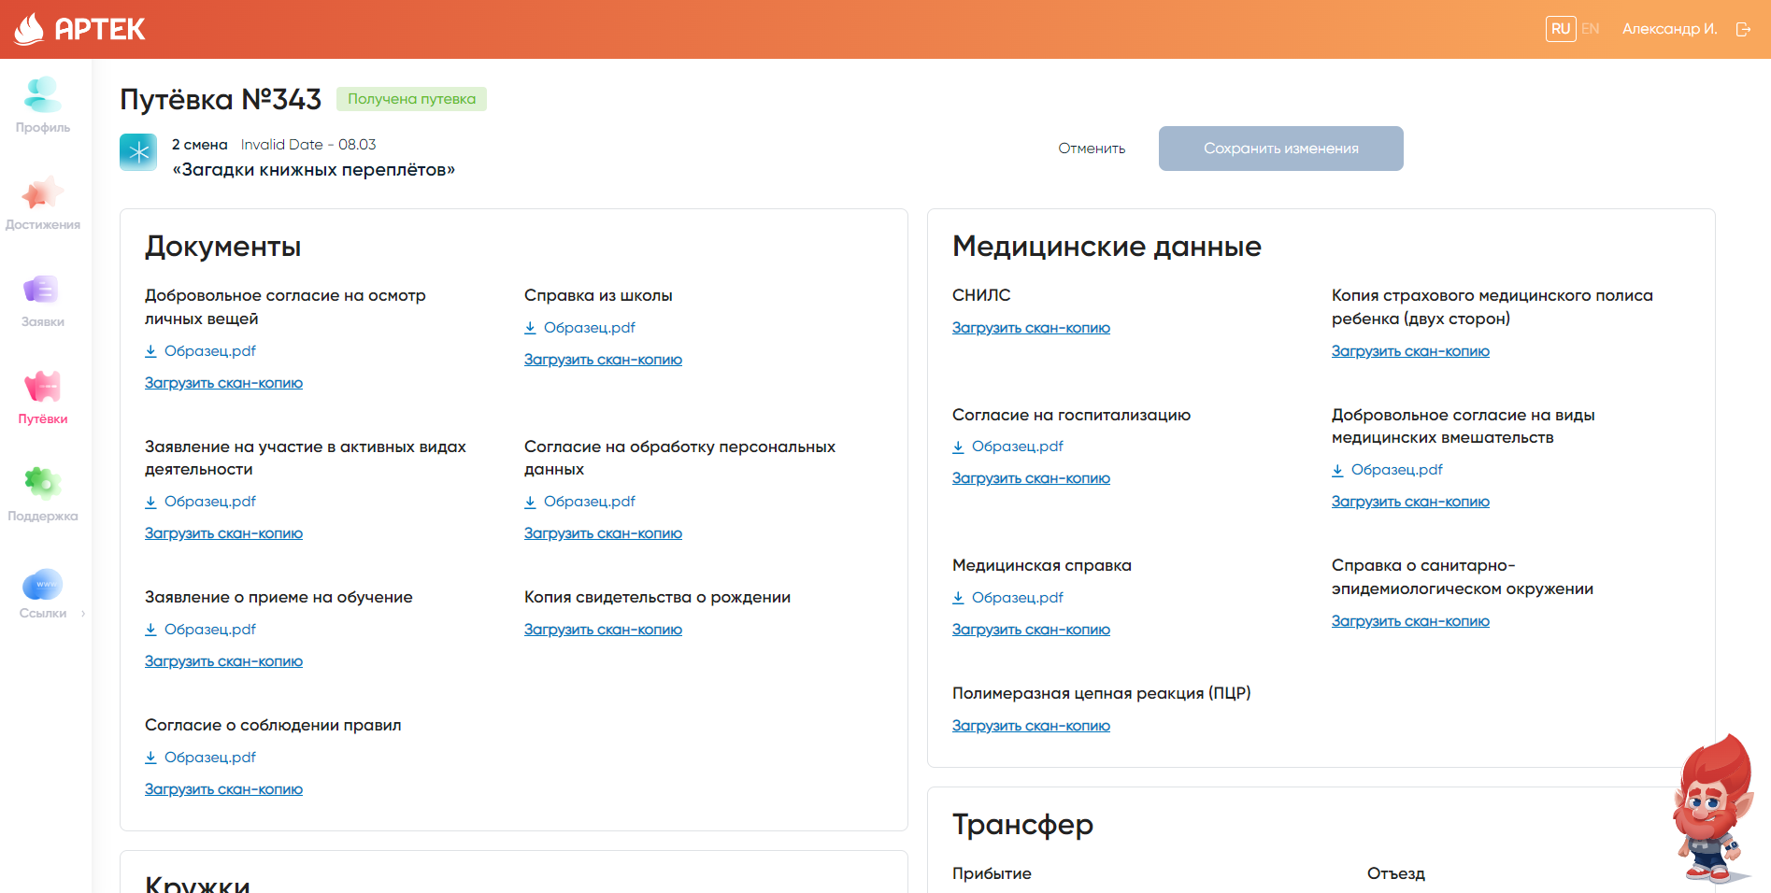

10. Be sure to include arrival and departure information, select date, time, place of arrival/departure.
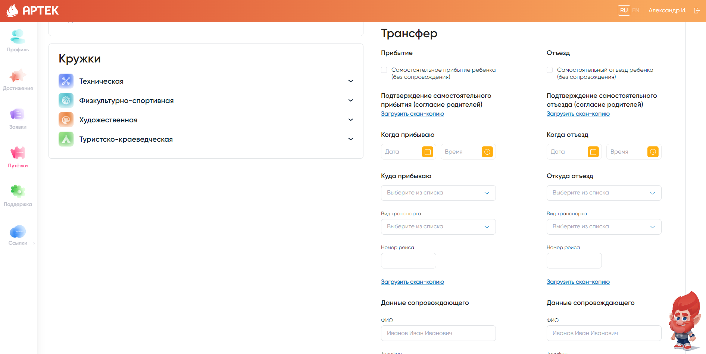

We are looking forward to seeing you in Artek Team!

Technical support for AIS Artek
Contact phone: 8 800 600-20-85
E-mail: assemblyinartek@artek.org

