Instruction for the participants to work in the automated information system “Voucher”.
Diplomatic mission: Children of the World. Stage 1.

Attention! If the child already has registration on the website http://артек.дети. Next step you need to go is step 5. Registration of the parent is not obligatory.

1 step | Registration in AIS «Voucher»:
Follow the link http://артек.дети (In any Internet browser)
Select the tab REGISTRATION
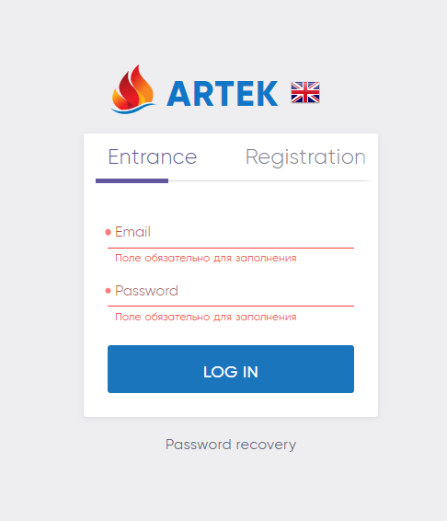
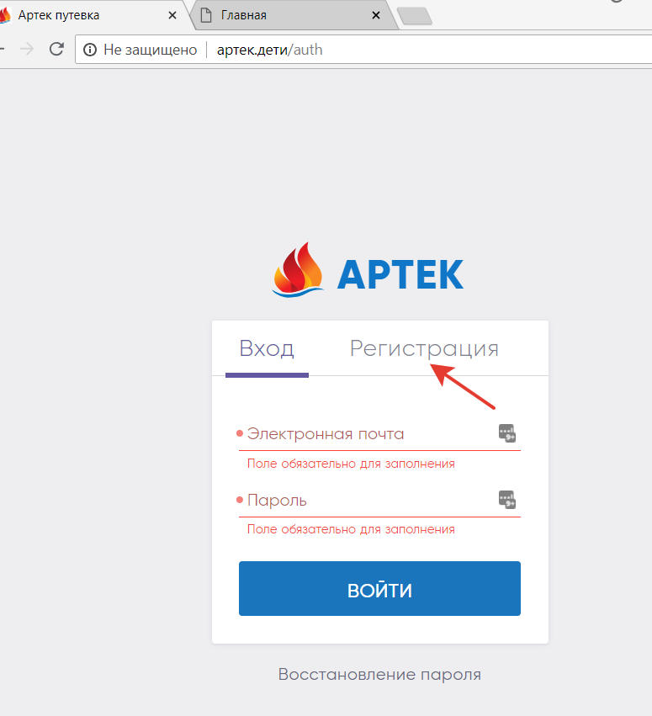
2 step | Filling in the registration fields:
- Fill in ALL the fields carefully! Enter a valid email address in the “Login” field, then you will get a confirmation of registration. Make sure you write and save your Login and Password.
- After pressing the Register button, you will not be able to adjust anything!
- Enter your Birth Certificate data and upload a scan copy of your Birth Certificate, for foreign citizens: data of your foreign passport.
- Click the REGISTER button.
- Go to your mail (specified as Login). By clicking the link in a letter from AIS, confirm Registration.
- You will be taken to the main page of your cabinet. Continue working in your Personal Account. If you need to get to the main page of your Account – click on the inscription ARTEK in the upper left corner.
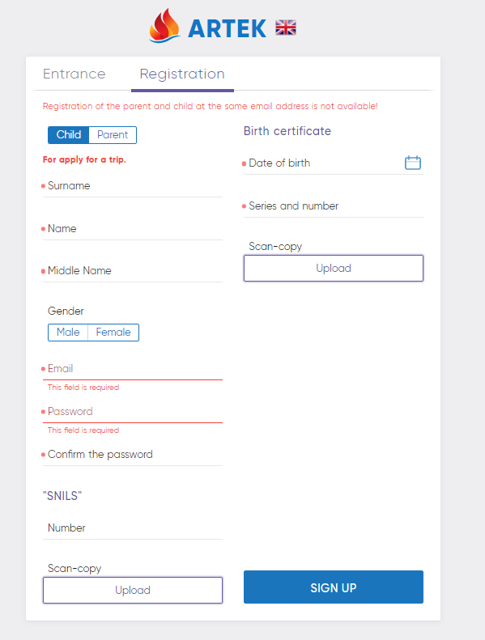
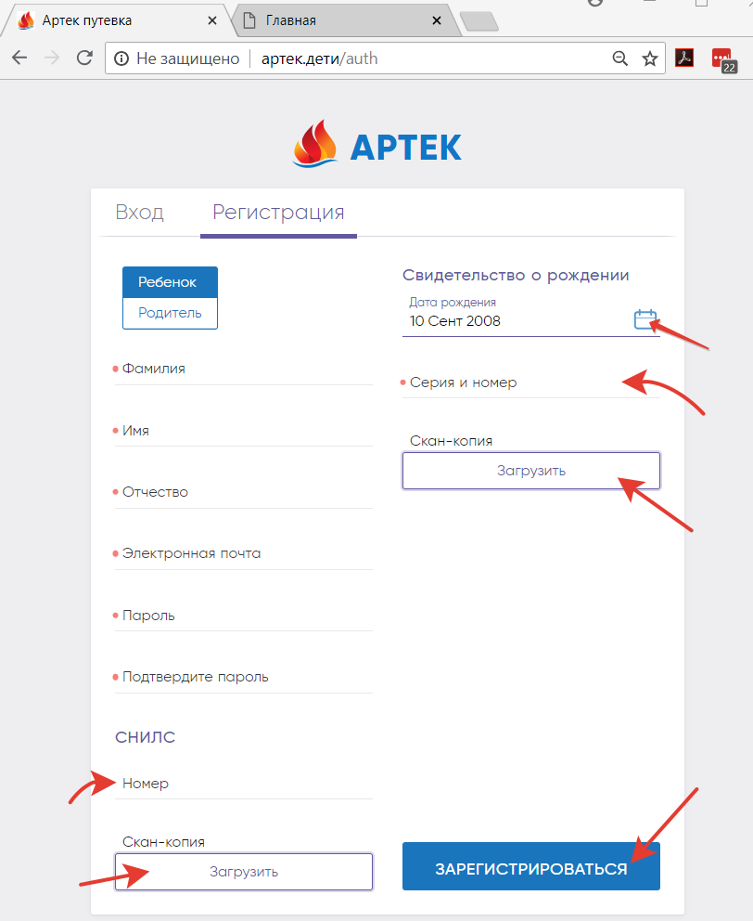

3 step | Entrance and work in Personal Account:
Follow the link http://артек.дети in Internet browser.
Enter your Username and Password. Continue working in your Personal Account.
 | 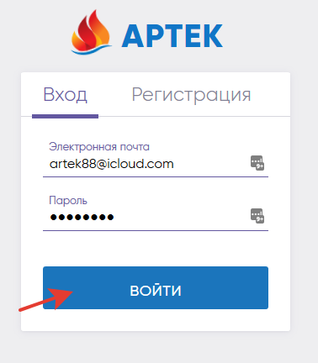
4 step | Filling out the profile:
 | To go to your PROFILE, click on your Last Name in the upper right part of the Cabinet.
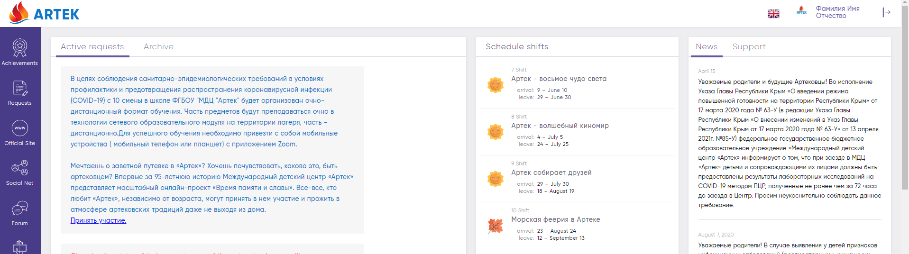
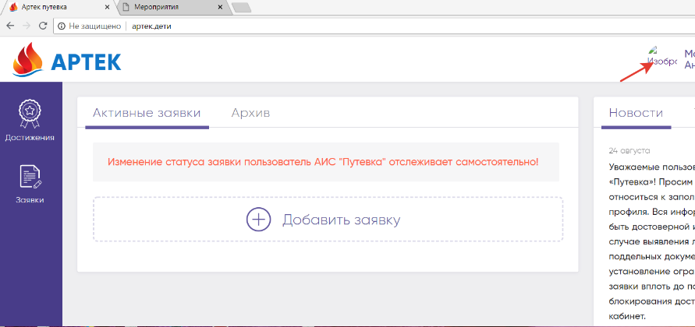
Some of the fields you have already filled in during Registration and their editing is already closed for you.
- Select the gender, the size of the clothes - activate by clicking. The selected value will be highlighted in Blue.
- Enter Your Citizenship. A drop-down list of options will appear by typing the initial letters in the desired line. Select the desired option.
- Fill in your address. Enter from the suggested options: Country, region, district, city, street, house and apartment number (if there is apartment number), similarly to the previous actions.
- Attention! In the REGION line select cities for Moscow, St. Petersburg and Sevastopol. In other cases, specify your Republic, Province, District or Region. If you live in a city, then the district is not specified.
- Fill in the information about the Parents – Full name, contact phone number and email.
- Upload the data and a scanned copy of the Birth Certificate. (MANDATORY for Russian citizens).
- In case if you have a citizen's passport, if you are over 14 years old, upload the data and a scanned copy of your passport.
- Press SAVE PROFILE.
 | 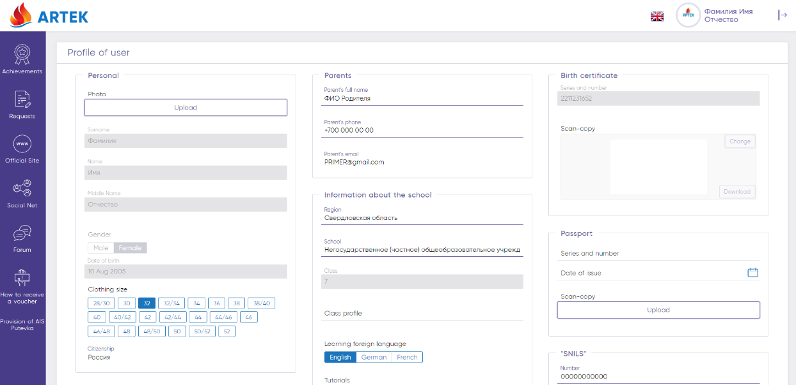

5 step | Adding a contest video:
You need to add your video to the video hosting (for example youtube.com)
Next, you need to prepare a file in text format (word or txt).
In the file, insert a link to your video clip.
Go to the ACHIEVEMENTS section (left menu on a blue background).
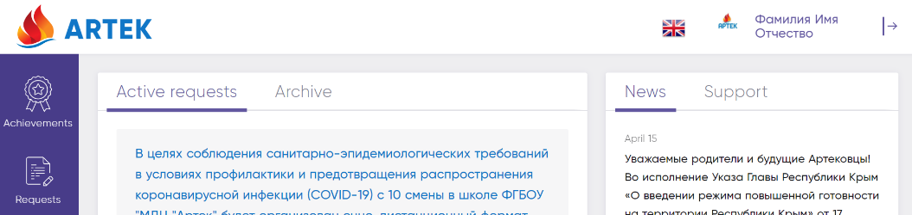
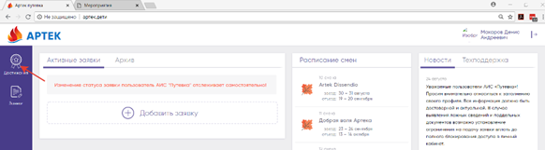
 | - Add an achievement from a partner
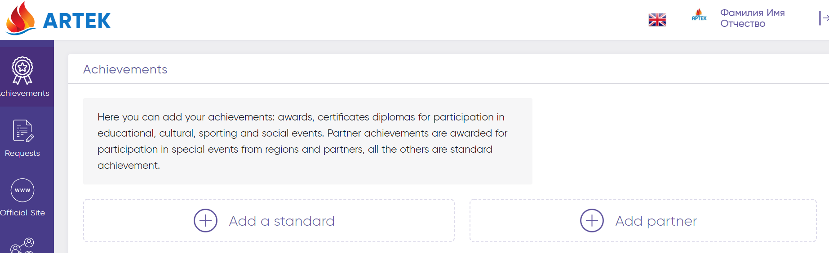
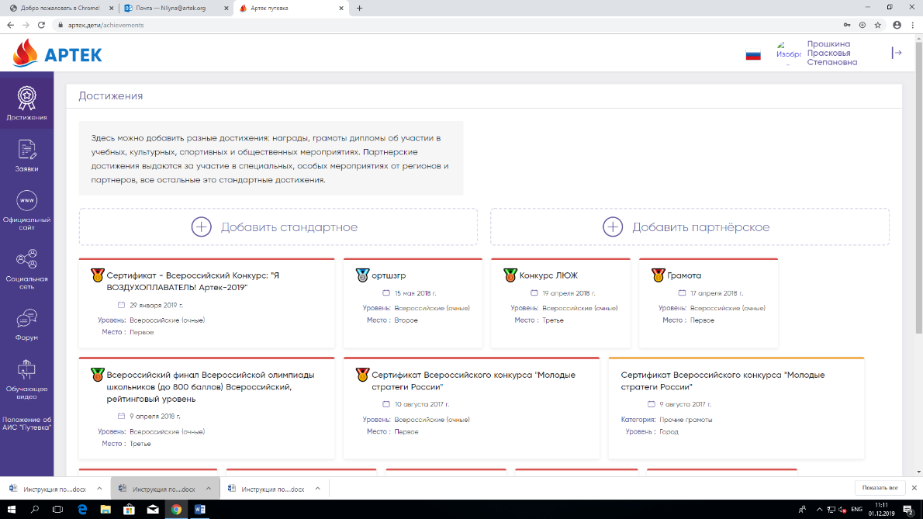
- Select the item “Diplomatic mission: Children of the World. Stage 1” from the list of available partners,
- Then click on the "Video" button,
- Choose any level (this will not affect your rating),
- Your video has been added!
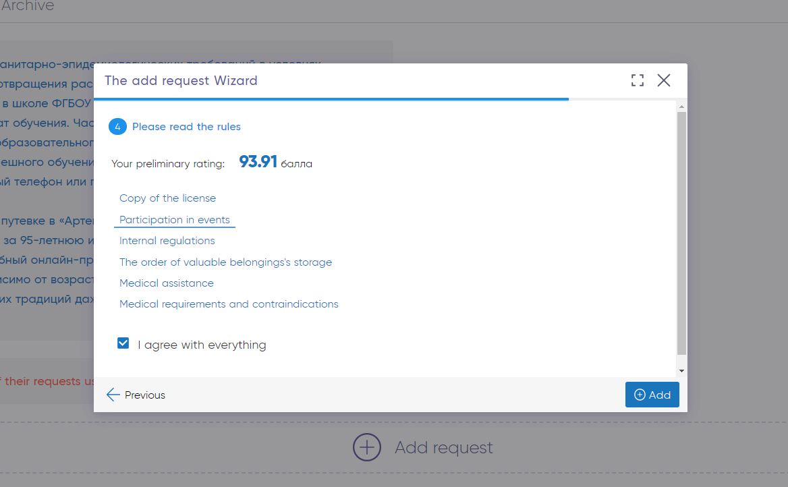

6 step Application submission:
- Press ADD APPLICATION
- Select type of the Application: «A voucher from a thematic partner».
- Select the item “Diplomatic mission: Children of the World. Stage 1” from the list of partners
- Then choose available session.
- When you will see achievements at the next step, click on them to choose which ones to attach to the application.
- You will see a rating (this rating does not affect the contest), but you will be able to add an application.

- After adding an application, the operator can see your application.
- Then the operator checks your application, and transfers to «Accepted» status.

Information and advisory support AIS «Voucher»:
Contact us by telephone numbers: +7 978 700 89 28; +7 978 734 00 10
E-mail: ais-putevka@artek.org
Working hours: everyday, with no rest days, from 8:00 to 20:00 (Moscow time)

